Experiment: 5
Simulation and Throughput Analysis of LTE-Advanced Carrier Aggregation
OBJECTIVES:
• To model an LTE-Advanced link using one component carrier.
• To extend the model to use multiple aggregated component carriers.
• To compare estimated throughput for different carrier bandwidths.
• To explain how carrier aggregation increases available transmission bandwidth.
PROGRAME CODE:
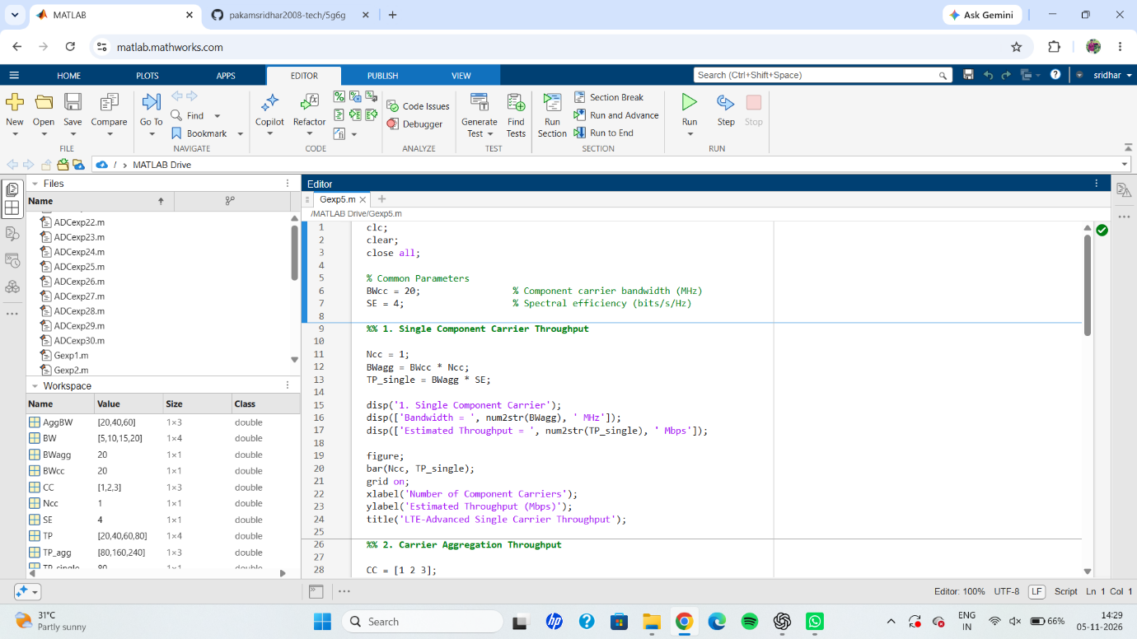
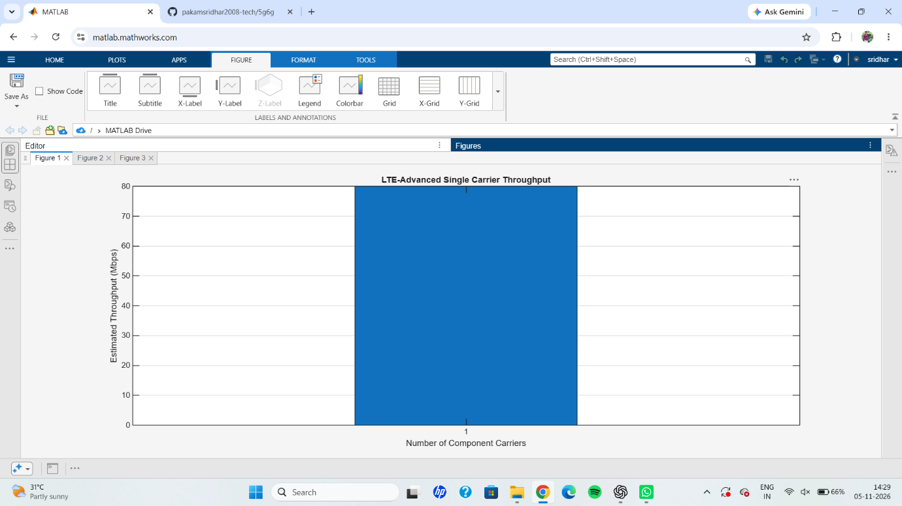
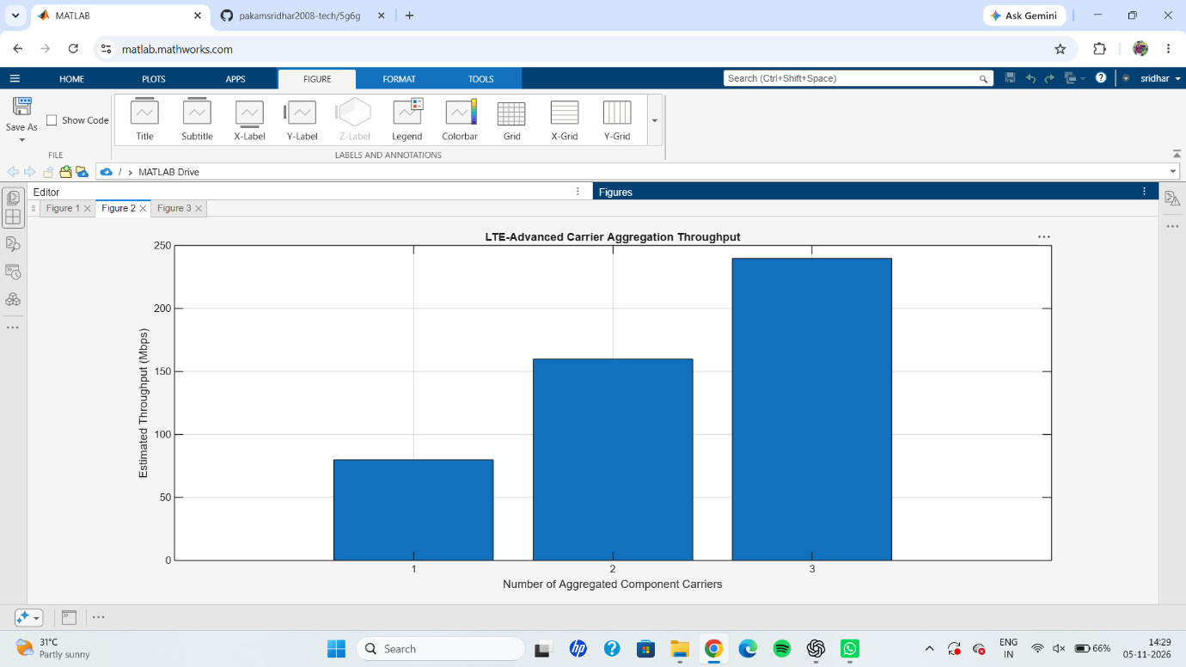
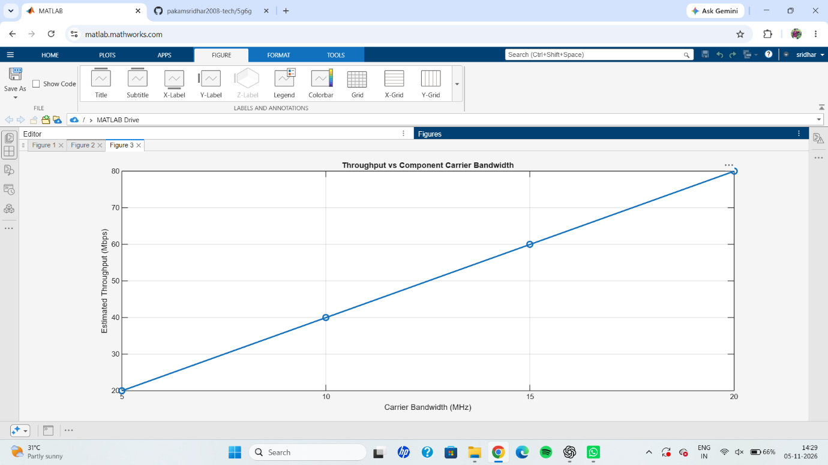
RESULT: The LTE-Advanced carrier aggregation and throughput analysis was successfully simulated using MATLAB. The results showed that a single 20 MHz component carrier provides an estimated throughput of 80 Mbps. By aggregating 1, 2 and 3 component carriers, the throughput increases to 80 Mbps, 160 Mbps and 240 Mbps, respectively. The bandwidth analysis also demonstrated that throughput increases with component carrier bandwidth. Thus, the experiment verified that carrier aggregation improves the total bandwidth and estimated data throughput in LTE-Advanced communication systems.

